NETHERLAND

Netherlands is located in the northwestern Europe. It borders the North Sea to the north and west, Belgium to the south and Germany to the east. Throughout the centuries the Dutch have had to protect themselves from the water by building dykes and draining lakes. The flat landscape is perfect for a cycle trip around the bulb fields, along the rivers and canals, through the picturesque fishing villages and historic towns, and past castles and other places of interest. There are nature conservation areas, recreation areas and theme parks throughout the country.

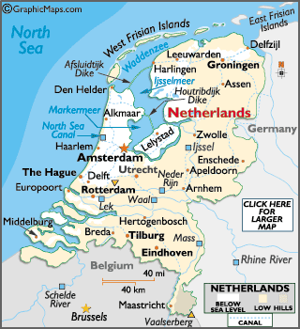

INFORMATIVE WEBSITES:
http://www.worldatlas.com/webimage/countrys/europe/nl.htm

VISA The visa is to be obtained prior to arrival in the country

INTERNATIONAL AIRPORT:
Amsterdam | Amsterdam Schiphol Airport | 15 km south-west of the city.

You will need to bring your own national driving license if planning to drive while in the Netherlands. A special driving license is not necessary. If, however, your license is not in English, it is advisable to hold an International Driving License. Although handy for getting from A to B, cars are a liability in the Netherlands's older cities and towns, which were not designed with automobiles in mind.

Distances between cities in Netherlands
The following table provides approximate driving distances between major cities in the Netherlands. Kilometers are shown in the lower left of the table, miles in the upper right.

City | Amsterdam | Den Haag | Utrecht | Maastricht | Rotterdam | Breda | Groningen | Brussels
Amsterdam | • | 35 | 24 | 133 | 45 | 66 | 113 | 252
Den Haag | 56 | • | 45 | 91 | 29 | 48 | 159 | 62
Utrecht | 39 | 73 | • | 110 | 35 | 46 | 117 | 105
Maastricht | 214 | 147 | 177 | • | 121 | 91 | 224 | 76
Rotterdam | 80 | 47 | 56 | 195 | • | 29 | 154 | 88
Breda | 107 | 78 | 74 | 147 | 47 | • | 159 | 62
Groningen | 181 | 256 | 189 | 360 | 247 | 256 | • | 218
Brussels (Belgium) | 405 | 99 | 169 | 123 | 141 | 99 | 351 | •

Points to consider:
• the minimum driving age is 18. • Driving is on the right and you must overtake on the left-hand side. • The driver and all passengers in the front and rear of the car must wear seat belts if fitted. • Watch out for cyclists, who are likely to be unpredictable and will usually be supported by the law - even in situations that seem ridiculous to drivers from other countries. • In urban areas note that cars always give way to trams (as does everything in the Netherlands). • Children below 3 yrs must travel in a safety seat in the rear of the car, while those aged 3-12 can travel in the front only with a special safety seat. • All vehicles must carry a red warning triangle in case of breakdown. It is also recommended that cars carry spare bulbs as the police will stop you if they spot defective lights. • the speed limit on motorways is 120/110km per hour (75/70mph), on the open road it is 80km per hour (50mph), and in urban areas it is 50km per hour (30mph).
CURRENCY:
Euro is the official currency. Currency: EURO (EUR), EUR1=100 cents. The National Central Bank will exchange Netherlands Guilder banknotes until January 1 2032 and coins until January 1 2007.
Notes: EUR5, 10, 20, 50, 100, 200 and 500
Coins: EUR1, 2 and 1, 2, 5, 10, 20 and 50 cents
Credit cards: All major credit cards are widely accepted throughout the nation for all manner of goods. Exchange One of the best ways to obtain money is to draw cash from ATMs, using an international credit or debit card. ATMs can be found in all towns and cities and they tend to offer a better exchange rate than traveller's cheques. Check with your bank before you travel to make sure your PIN number will work in The Netherlands. Check also which ATM systems are compatible with your card.
International traveller's cheques are accepted, these and currency can be changed at exchange offices (GWT) at Schiphol airport, railway stations and border crossings. It is possible to change currency and cheques at hotels but the exchange rate is usually less favourable. Popular destinations, including Amsterdam, will have highstreet bureaux de change in tourist areas.
Telphone
International dialling code: | 31
Area codes: | Amsterdam: 20, Haarlem: 23, Rotterdam: 10, The Hague: 70
Area codes are preceded by 0 when dialing within the country. You can make calls from post offices or public phone boxes. Most public phone boxes will only accept phone cards, which you can purchase at tourist information centers and post offices. Cheap rate telephone calls can be made between 20h00-08h00 Mon-Fri.

GETTING AROUND:
Getting There
Air: The main airport by flight to Netherlands will be traveling via Amsterdam Airport Schiphol. It is the biggest International airport in the country.
Train: From Schiphol ther are also excellent railway connections to The Hague, Amsterdam, Utrecht and most large cities have direct train service. the best mode of transport in and out of Italy. Travel by train is the best. The train travel is Kilometer wise but as distances are not that big, it generally does not cost much.
Bus: Buses ply the smaller routes.

CLIMATE
Lots of tourists visit Netherlands in the month of summer. Spring is also a good time to visit the country, as the bulb flowers are in full bloom in this season. Summers are generally warm with changeable periods, but excessively hot weather is rare. Winters can be fairly cold with the possibility of some snow. There is no denying that spring is the best time of the year to sit by the canals or take a bike trip through the country.

Climate chart for Amsterdam
TEMP | JAN | FEB | MAR | APR | MAY | JUN | JUL | AUG | SEP | OCT | NOV | DEC
MAX IN C | 4 | 5 | 8 | 11 | 16 | 18 | 21 | 20 | 18 | 13 | 8 | 5
MIN IN C | 1 | 1 | 3 | 6 | 10 | 13 | 15 | 15 | 13 | 9 | 5 | 2

The weather is very unpredictable in the Netherlands; it can be extremely changeable from day to day but also year to year. Spring is the driest season to pay a visit. Summers are quite warm, with the warmest weather occurring during July and August. Winters tend to be quite mild, although a very cold spell during January or February is not uncommon.
Temperatures range from around zero in winter, from November through February, to 20-25°C in the height of summer during July and August. There is an even distribution of rainfall throughout the year, so be sure to pack waterproofs at any time of year and waterproof shoes are essential. Evenings are cool, even during warmer summer months, so make sure you pack a jumper.

TIME:

Netherlands is 4 hours and 30 minutes behind India.

CLOTHING:
Required clothing, according to the season, with light to medium weights worn in warm months and medium to heavy weight in winter. Rainwear is advisable all year round, since rain is spread pretty evenly over the year. Summers are lovely but along with your shorts and beachwear pack a light-weight raincoat - the odd shower cannot be ruled out. Winter winds can be cold and you should certainly wrap up well in January and February. The average temperature in these months hovers just above 35F. One of the nice things about Holland is that the Dutch are relaxed about clothes. You wear what you feel good in - particularly in Amsterdam where an opera audience happily turns up in jeans and t-shirts. Which doesn’t mean you cannot dress up? Men should bring a tie and women a skirt or dress if you plan dining up-market. Otherwise feel free.

ELECTRICITY:
The voltage used is 220 volts.

DAILING CODE:
00 31

CUISINE
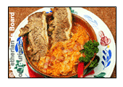
An historic exception to the generally unremarkable Dutch table is, of course, the range of cheeses. The centre of the cheese trade is the province of Noord Holland, which includes the towns of Alkmaar and Edam. The Dutch also like their curries and some of the hottest culinary inventions around grace the tables of the nation's curry houses. Below are some typical Dutch dishes:
Stamppot: Single-handedly summing up Dutch cuisine, Stamppot is a nourishing but unimaginative hotch-potch of mashed potato and other vegetables. This veg-fest is often augmented with something meaty - normally a huge sausage.
Pannekoeken: Dutch pancakes are famous the world over and deservedly so. Sweet and savoury varieties are delicious and widely available from stalls or dedicated pancake houses.
Poffertjes: A variation on the pancake theme these are small sweet versions of the delicacy and are a delicious snack. Look out for them for a sugar fix available from street stalls.
Fritjes: French-fries Dutch style - meaning they come smothered in mayonnaise. If you like other sauces then you're quite welcome to slather them on as well; a vast range will undoubtedly be on offer.
Croquetten: These are deep-fried croquettes normally filled with meat, although cheese varieties are available. A great finger-food snack available from street vendors and especially good with mayonnaise or the weak mustard that Dutch fastfood joints invariably have in abundance.
Vlaai: Basically a fruit pie or pastry with origins in the south of the country.

TIPS:
This is a matter of personal discretion. Tips are appreciated and expected for good service in restaurants and other places. Although restaurant bills often include a service charge, this amount is not typically for the waiters/staff. A typical tip is approximately 10%.

LANGUAGE:
Dutch is the official Language, though in the hotels and your guides are well versed in English.

SHOPPING and MUST BUYS:
Shops generally open from 09h00-17h00 Mon-Sat.
Netherlands is known for its gorgeous tulips and their bulbs. Delicious cheese, chocolate, beer and cookies are always a hit. Dutch wooden clogs or wooden shoes are also symbols of the Netherlands, which are worth buying as a souvenir.
Stores in the Netherlands charge a sales tax of 15.97% on consumer goods, which is included in the overall price. When leaving the Netherlands, non-EU tourists can apply for a tax refund on goods bought. Most countries offering a tax refund specify a minimum amount that must be spent in a particular shop to claim a refund. In the Netherlands, the minimum purchase to qualify for a refund is approx EUR 50 in one store in one day. To reclaim tax you need to request a tax refund form, when you make a purchase, which will state the amount of refund due. Customs officials must stamp these documents as you leave the country and the refund will be processed and sent to you.
Alternatively, you can purchase goods from shops participating in the Tax-free Shopping programme (look out for the Tax-free Shopping logo displayed in the window). Simply show your passport when you make a purchase and you will be given a Tax-free Shopping cheque showing the refund you are owed. As you leave the country, customs officials will stamp your cheques. You can claim your refund from the Tax-free Shopping desk or have it sent to you. For further information, Email: info@taxfree.nl.

CITIES:
AMSTERDAM

Amsterdam is often referred to as one of the most colourful cities in the world. It is a place of many places of interest, famous museums, and cozy pubs.
It is an amazingly beautiful city, which has the advantage of being very compact and therefore easy to explore on foot. The city is a maze of canals with several bridges spanning the canals, many dating from the 17th Century. The buildings lining these canals only add to the charm, and most of them were also built in the 17th century during Amsterdam’s “Golden Years” when trading was flourishing.

Getting There
Air: Amsteram Schipol Airport is situated 15 km south west of the city. Easy jet and other low cost carriers serve Schiphol, providing a fairly economical way to city-hop to Amsterdam from other spots in Europe.
Train: Schiphol airport has a direct train station, with atleast seven trains an hour to Amsterdam central.
From Schiphol there is a direct train to AMS Central station, for approx 3.60 Euros in 15 min. Most trains arrive and depart from Amsterdam Centraal Station, located between the old centre and the IJ waterfront. Other train stations are Bijlmer-Arena, Amstel, Muiderpoot(all southeast), RAI, Amsterdam-zuid (both south), Lelylaan and Sloterdijk (both west)
Road: Taxis from Schipol are expensive: legal taxis have blue number plates, others should be avoided. Some hotels in AMS and around the airport have a shuttle bus service as well. Arriving by car to the city centre is fairly discouraged due to narrow streets and high parking rates.

Getting Around
AMS centre is fairly small, and almost flat, so one can easily get to most tourist destination on foot from the train station, within 30 min. A pleasant way to cover a lot of ground is to rent a bicycle. The city is very bike friendly, and there are separate bike lanes on major streets. There are bike rentals shops at stations, and around the city. Bikes cost about 9 Euros to 20 Euros approx per day. The tram is the main form of public transport. Regional buses, and some suburban buses, are operated by Connexxion and Arriva. The Standard ticket for bus, tram and metro is the strippenkaart, which are available fro machines in the metro and railway stations, from GVB office opposite Central Station, and from supermarkets, newsagent. Alternatively one can also get a 24, 48 or 72 hour all zones bus/rail/ tram pass for a reasonable price (approx 10 Euros for 48 hrs).

Attractions

Van Gogh Museum

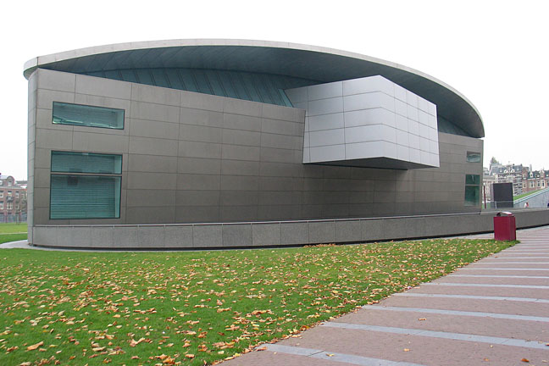
Portrait of Van Gogh

Nowhere else in the world can you see so many Van Gogh paintings in one place. The museum has approximately 200 paintings and 500 drawings by Van Gogh and his contemporaries.
Museum: Opening times daily 10:00 to 18:00, Friday 10:00 to 22:00 Ticket office: daily 10:00 to 17.30, Friday to 21:30
The museum shop is located on the ground floor of the museum. Here you will find a wide range of literature on the Van Gogh Museum, the life and work of Vincent van Gogh and that of his contemporaries. It is also the right place for the most beautiful, high quality reproductions, stationery and other souvenirs. The income generated through purchases is used to support the Museum and especially to fund new acquisitions for the collection. The museum shop is only accessible if you are visiting the museum, each day from, daily 10:00 to 17:45, Friday to 21:45, except 1st January.
Restaurant: The museum restaurant serves a range of snacks and beverages, simple lunch options (soup, quiche, salads, sandwiches, etc.) and a hot meal on Friday evening. The restaurant is accessible only through the museum and is open daily from 10:00 to 17:30, Friday to 21:30.
Library Museumplein 4: Monday to Friday 10:00 to12:30 and 13:30 to 17:00 Closed 1 January Location: Paulus Potterstraat 7, Amsterdam.
Rijksmuseum
The biggest and the most important museum in the Netherlands, with a large and varied art collection. The only museum in the Holland showing a complete overview of Dutch history. The main building is closed for major renovations until December 2008. The Phillips wing is still open to the public, and is functioning during the renovations as mini-Rijkmuseum. Location: Stadhouderskade 42, Amsterdam, Tel. +31 206 747 047 Opening hours: 09.00 am to 06:00 pm, Friday 09:00 am to 10:00 pm. Closed on 01 Jan.

St. Nicolaas Kerk

A one minute walk from the Centraal Station lays the St. Nicolaaskerk, one of the better-known churches in Amsterdam. Dedicated to the patron saint of the sailors, the church was completed in 1887 and it became the leading Catholic Church in the city, replacing a number of Amsterdam’s secret churches from the era of the Alteration.

Amsterdam Historical museum

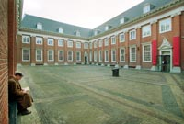
The Amsterdam Historical Museum tells the compelling story of how this city grew from a small medieval town into a modern city. Go on a fascinating journey of discovery down seven centuries of the city's history, through the intimate rooms and courtyards of this former Civic Orphanage, where Amsterdam’s orphan's once lived. Guided tours available, a quick tour for those with limited time is available at the museum shop. In our restaurant David & Goliath you can enjoy a coffee and sandwich, or try our famous pancakes.
Location: Kalverstraat 92
1012 RM Amsterdam
Opening Hours: Monday - Friday: 10.00 - 17.00 hours
Saturday, Sunday and public holidays: 11.00 - 17.00 hours
Close: Closed: 1 January, 30 April, 25 December
To get there-transportation
(tram) 1-2-4-5-9-11-14-16-24-25 stop Spui
(museumboat) stop 4
(parking) parking Rokin
parking garages Bijenkorf, Het Muziektheater
in front of the museum there is a stop for busses (no parking)
it is a 15 minutes walk from Central Station
Madame Tussaud’s Scenerama
In Madame Tussaud’s on Dam square in Amsterdam you can meet lots of famous waxworks. You can shake hands with Johan Cruijff, or give Bon Jovi a kiss, embrace Michael Jackson and lots more. Apart from waxworks from this century, one can also meet people fro Holland’s Golden Age, such as the famous painters Rembrandt, Vermeer, Pieter and many more. If you want to know what Amsterdam looked 300 years ago you should not miss this part of the Scenerama.
Location: Dam 20, Amsterdam, Tel +31 205 221 010. Opening hours: 10:00 am-6:30 pm. Mid July – August 09:30 am – 09:00 pm. closed on 30th April.

The Royal Palace
Located across the national monument, The Royal Palace or Koninklijk paleis dominates the Dam Square with its presence. The Royal Palace, designed by Jacob van Campen, was built in 1648, an Amsterdam’s city hall. When Louis Napoleon arrived in Amsterdam, 1808, he had the city hall turned into a palace, which was destroyed by fire. Although this palace is still the official residence, the royal family lives in The Hague. However, Queen Beatrix does host official functions here. The interior of the palace is open for public if no ceremonies are scheduled.

Anne Frankhuis (Anne Frank House)
The very popular Anne Frank House annually attracts roughly aboult half a million people. Its historic home where Anne Frank, her family and four other Jewish people hid from the occupying Germans during World War II, after fleeing their native Germany.

De Nieuwe Kerk
Amsterdam’s Nieuwe Kerk (New Church) built in the late 14th century, sits on a corner of the Dam, next to the Royal Palace. Its architecture as we see it today is predominantly Gothic. Many famous Dutch-men are buried inside the church. Also inside, the beautiful pulpit is considered a baroque masterpiece.

Netherlands Maritime Museum
The highlight of the maritime museum is the newly built reconstruction of an Old Dutch East India man that is moored just offshore.

Diergaarde Blijdorp
One of the most beautiful zoos in Netherlands. One can walk through the shark tunnel in the Oceanium or watch gorillas play around. Especially for kids there is a great wooden playground. website: www.blijdorp.nl. Location: Blijdorplaan 8, Opening hours: 09:00 am – 06:00 pm from April to October.

Excursions
For a Half Day – Houseboat Museum
The Houseboat Museum gives you the unique chance to personally experience how exactly life is on board houseboat in an Amsterdam canal. Unique locations in the Prinsengracht canal on the edge of the Jordaan provide a fitting background for the museum vessel. The spot is only 5 min. walk from the Anne Frank House and its nearby Westerkerk church. Living on the houseboat sounds like an alluring way of life and its increasingly popular in the Amsterdam area, partly due to the city’s chronic housing shortage.

For a Whole day- The Hague
The Hague is connected by toll-free motorway to AMS (A4 and A44). Also, through its 2 central railway stations, The Hague has direct trains link to Schipol Airport (30 mins) and to Amsterdam city centre (45 mins). The city offers great architecture like the medieval complex of the Bennenhof.

The Binnenhof

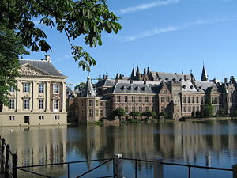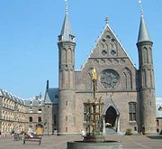

Binnenhof is a collection of buildings in Hague is the centre of power in the Netherlands. Parliament sits in the building, and the prime minister has his offices there. Its history begins in the thirteenth century when Count Floris IV of Holland established a residence on the site. It became the administrative centre of the counts of Holland, and the village of The Hague grew up around it. Location: Binnenhof Information Center,
Binnenhof 8A; The Hague, Zuid-Holland 2513 AA; Netherlands

Madurodam

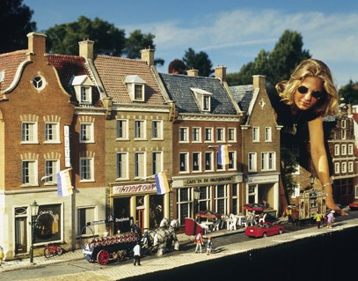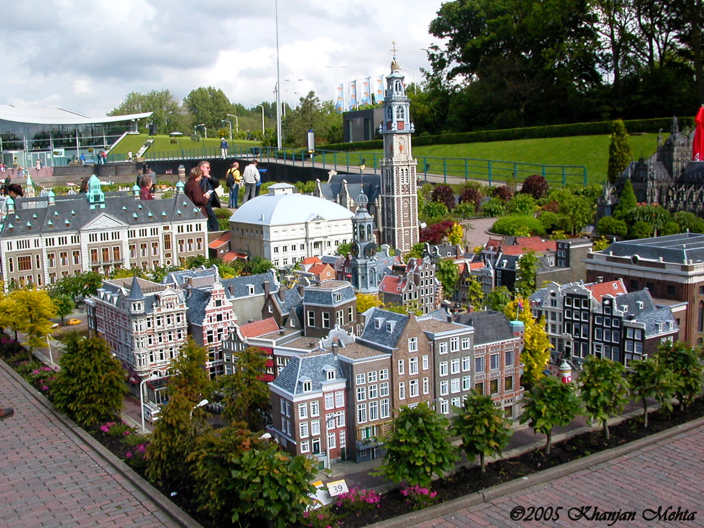
Madurodam is the smallest city in the Netherlands. All the items on view here are 25 times smaller than in real life! Be a giant among the palaces, ships and medieval houses, and put on your seven-league boots to walk around a football stadium. These miniature buildings are all scale models. The canal houses of Amsterdam, the Alkmaar cheese market and parts of the Delta Works, all replicated in minute detail on a 1:25 scale.All is set in beautiful gardens. Windmills turn, ships sail trough the harbour and trains are traversing the city on the world's largest miniature railway. 13 March until 26 October 2008 Exhibition Sesame Street in Madurodam.
By car: The Hague, follow the signs for ‘Scheveningen Haven’. Then follow the signs for ‘Madurodam’. Public Transport: from Hague Cnetral Station take tram 09 or bus 22. You can get out in front of Madurodam. Location: Geprge Maduroplein 1, The Hague, Tel. +31 703 553 900. Opening hours: Open daily 8:00 am – 7:30 pm from 22 March to 20 May. Website: www.madurodam.nl.
website: info@madurodam.nl or www.madurodam.nl Opening Hours:2 Sept. 2007- 12 March 2008 - 9:00 - 18:00; 13 March - 30 June 2008 - 9:00 - 20:00; July - 1 September 2008 - 9:00 - 23:00; 2 Sept.- 31 December 2008 - 9:00 - 18:00. Opening times may differ due to Madurodam by Light. The ticket counter closes one hour earlier. Madurodam is open all year round.

Keukenhof
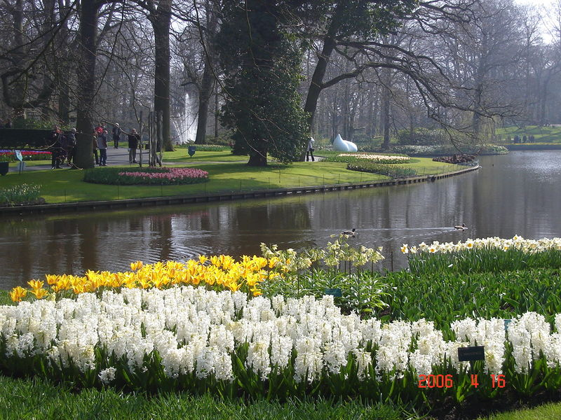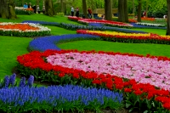

Kuekenhof is the most spectacular flower garden, when millions of tulips and other bulbs flower.Tulips form the core of Keukenhof. The name says it all: these bulbs bloom in spring. Keukenhof is therefore only open during this period. 32 hectars of traditional and modern garden landscaping. The other months are intended for maintenance activities at the park, and obviously for planting the bulbs, so that we can present colour and flowering splendour to you the following spring.
Restaurants: At Keukenhof there are various restaurants with terraces that look over the gardens. Perfect place to enjoy a cup of coffee with a slice of freshly baked cake, lunch or dinner.
Location: In 2008 Kuekenhof is open from 20 March to 18 May (including Sundays and public holidays) Keukenhof is open from 08:00 to 07:30 daily (ticket office closes at 06:00)

To get there:
With the train you can travel via Rotterdam, Utrecht or Amsterdam to Leiden. From the central train station in Leiden (Leiden CS) bus number 54 'Keukenhof Express' of connexxion drives directly to Keukenhof. This bus leaves twice every hour. From Haarlem station bus 50 and 51 go to Lisse, from there you can take a shuttle bus to Keukenhof. It is possible to purchase a combi ticket at the Connexxion desk or from the bus driver for bus and entrance to Keukenhof.
Bus nr 58 is an immediate connection from Schipol to Keukenhof.
There is no combination ticket available for train+bus+park. For more information on public transport call 0900-9292 or look on www.9292ov.nl.

Indian Restaurants in Rome:

Taj Mahal -
Add: Marie Heinekenplein 1,
1072, MH
Tel. 020 679 3804
Website: www.tajmahal-amsterdam.nl
Vijaya Address: Gledersekade 23 Tel: 020 420 5225; website www.vijaya.nl
Mayur Address: Korte Leidsedwarsstraat 203, 1017 RB; Tel: 020 6232 142 Website: www.mayur.nl

ROTTERDAM

The second largest city after Amsterdam in the Netherklands is Rotterdam. This lies aprrox 50 miles to the north. The city’s street scenery is characterized by the large presence of people from North Africa.

Getting there:
Rotterdam has a small airport. One can get there from London, Berlin, Oslo, Stockholm and many more cities with low cost airline Transvania.
Train: there is a train every half and hour from Schiphol Apt to the city, making it possible for one to fly to AMS and then take a train to Rotterdam (about 50min). From Rotterdam, trains run to many destinations in Netherlands, including Amsterdam, The Hague, Delft, Eindhoven, Maastricht and Groningen, via Zwolle.
Bus: Bus no. 33 runs regularly to the city centre and reaches the destinations in 20 min. for approx 3Euros.
Car: Rotterdam is easily accessible by car.
Ferry: Rotterdam being the biggest port in the world can be reached by ferry from Rom Kingston upon Hull or Harwich in England or from Rosyth in Scotland.

Getting around
Rotterdam has a tramway and a metro system. But getting around by bike is stii faster way to get from A to B within the city. The public transport in Rotterdam is very well organized. There is a subway, buses and an extensive system of short distance trains: Trams which allows to quick and easy. Subway Metros depart every 4 min. at daytime. In the evening they depart every 15 or 30 min. Except for buses on Friday and Saturday night there is no public transportation after midnight. Rotterdam was built on a no. of islands and if one wants to travel from shore to shore, the nicest way to travel is by Water taxi. This speed boat escort you over the Maas to the Northern Island and back to the Mainland.

Attractions:
The area around train station Blaak
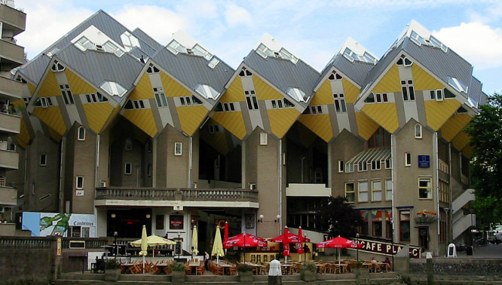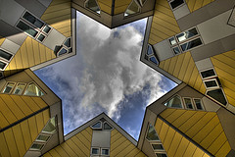

The area was destroyed by a German bombardment during the World War II, forcing the Netherlands to surrender. After the war, it has been reconstructed with all kinds of strange and fascinating buildings. Especially the Cube Houses are worth seeing. The KijkKubus is the fully furnished museum home. The interior was specially designed to give visitors an impression of how you can live in a cube home.The market place here on each Saturday morning; it is definitely worth a visit to get acquainted with local food and customs. And the ‘Old Harbour’ is around the corner for a drink and a bite to eat.

Windmills of Kinderdijk

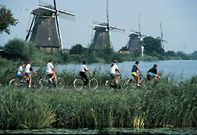

The sight of Windmill sails spinning in the breeze stirs the soul; of a true Hollander. Kinderdijk, a tiny community between Rotterdam and Dordrecht, on the south bank of Lek River, has 19 water pumping windmills; that means 76 mills sails, each with a 14-yard span, all revolving on a summer day. It’s a spectacular sight, and one important enough for Kinderdijk to have been placed on UNESCO’s world Heritage list.

The Kuip

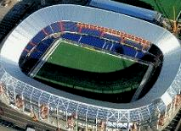
The Feijenoord Stadion, better known by its nickname de Kuip (the Tub), is a stadium in Rotterdam.
The Kuip, football stadium of the club Feyenoor is a must see for every traveler who visits the city.

Rotterdam Zoo
With the visitor’s count of around 1.5 million people a year, the Rotterdam zoo is one of the biggest attractions in the Netherlands. The zoo remains open all year long from 9:00 am to 05:00 pm and easily accessible by public transport. The Rivera Hall entrance is very close to Rotterdam Central station. One can either take a 12 min. walk or choose the bus service. Rotterdam Zoo is located in the heart of Rotterdam. This zoo has placed a webcam in the sea lions quarters. These allow you to keep track of what they are doing. The feedingtimes are 9 am, 10.30 am and 5.30 pm.

Maritime Museum Rotterdam
This Maritime museum hosts a great selection of large ship models, navigational instruments and information and objects about Holland’s rich naval tradition.

Excursions
For Half Day- Euromast and Space Adventure

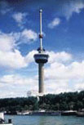
This slender tower, 188mts (611ft.) tall, is indisputably the best vantage point for an overall view of Rotterdam and its environs. More than that, though the tower contained interesting exhibitions, a restaurant and an exciting Space Cabin ride that emulates a rocket take-off. A super – fast elevator brings you up to the viewing platforms. One of the best ways to look at the Rotterdam city!

Indian Restaurants in Rotterdam

Indian Paradise
Address: Admiraal de Ruyterweg 20a,31 AC.
Tel no. +31 (0) 10 41 21465
Website: www.indiaparadise.nl

Ambala Tandoori Take Away-
Address: Vierambachtsstraat 147a, 3022AL
Tel No: +31 (0) 104 258256

Light of India
Address Goudsesingel 256 & 260
Tel: + 31 (0) 10 4141777

For Whole day
Utrecht

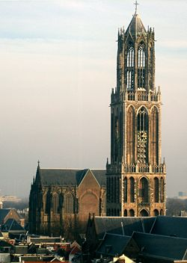
Utrecht is about 35-45 min ride by train from Rotterdam Central Station as there are direct trains connecting to Utrecht Central Station. Utrecht is a central Dutch city with a long history and it’s the fourth largest city in the Netherlands. Utrecht central station forms the hub of the Dutch rail network, and is easily acceible directly, or with one change of train, Utracht is a pleasant “Old town” with good restaurants and interesting antique stores. Attractions are Central Museum, Domkerk

Alkmaar
The Netherlands has long been associated with the making of cheeses, and a visit to the cheese market at Alkmaar is as much a cultural experience as it is a place to buy the country's most famous export. The market square is filled with large yellow cheeses in their thousands as the local producers flock to the town to sell their wares.
If this isn't enough then you'll have to pay a visit to the Cheese Museum, which documents the history of the town and its cheesy product. There's also a beer museum chronicling the other national obsession. Whatever your cilinary tastes, the town makes for a relaxing getaway, and is a pleasant slice of small town Holland.

Zandvoort
Zandvoort, near Haarlem, is the country's most popular coastal destination, with long, white beaches. Bloemendaal is the trendiest of this region's beaches, with some great clubs and bars, home to the beautiful people who decamp from Amsterdam in summer.
Near to Zandvoort is the Kennemer Duinen reservation area, a designated area of natural beauty. With cars banned and even planes prohibited from flying overhead, the 4000-hectare site is great for exploring by bike or foot and contains a wealth of flora and fauna. All these areas are easily accessible from Haarlem - itself only a short train rides from Amsterdam. From Haarlem continue your journey by bicycle, you can hire them from the train station at: Rijwielshop-Pieters, Stationsplein 7, Tel: +31 (0)23-531-7066.
Delft
Delft is approx 1 hr away from Delft by train; the charming town of Delft will feature significantly in many Netherlands itineraries because of the famous blue porcelain that has been produced here for centuries.
Climb the steps of the Nieuwe Kerk (New Church) for the best view over the rooftops and make sure you visit the Royal Delft factory where the famous blue pottery is still manufactured by hand as it has been since the 1600s.

